Genetics: exercises
Chapter 1
From gene to protein

1. Example
Gene (DNA):

5’ TCGCC ATG GAA GCA TCA CCC TAG 3’ (positive strand or forward strand)
3’ AGCGG TAC CTT CGT AGT GGG ATC 5’ (negative strand or reverse strand)

Alone, the negative strand should be written:
5' CTA GGG TGA TGC TTC CAT GGCGA 3’

messenger RNA:

5’ UCGCC AUG GAA GCA UCA CCC UAG 3’

Protein:
Met–Glu–Ala–Ser–Pro–(stop) (= MGASP)

In the exercises on gene, if there is no any mention, please consider the provided sequence as a positive strand, direction 5’- 3’.

Example on Chargaff’s rule in a double strand DNA:
5’ T T A T A T G C C C A T G G C C G C A G C C G G 3’
│ │ │ │ │ │ │ │ │ │ │ │ │ │ │ │ │ │ │ │ │ │ │ │
3’ A A T A T A C G G G T A C C G G C G T C G G C C 5’

2. Problems

- This is the sequence of the first exon of a gene (negative strand):
5’ –TCCGCACAGGGTTCCCCAATGCATTTTCCT -3’
Write the complementary DNA sequence (positive strand).
Determine the mRNA and peptide sequences encoded by this gene exon.
Make solution for ex in here

2. The following sequence is located at the beginning of a gene.
The underlined part corresponds to an intron, which flanks two exons.

ATTAGCCATGCTCTCCGTCCCAACTGTAAGTATGCGCGAGATCGTTACCAGGATGATTGT…
Determine the sequence of the corresponding mRNA and peptide.

3. The following sequence (positive strand) is located in the middle of a bacterial gene: CTCTCCGTCCCAACTGATGATTGT
What are the possible peptides corresponding to this sequence?

4. Write the 3 possible correct codes for the following polypeptides (Multiple answers several codons code for different amino acids),
- Leu – Val – Cys – Lys - Stop

- His – Met – Ser – Thr – Stop

5. Here is the sequence of a gene:
PROMOTER: TTCCCTAGATAGAGATACTTTGCGCGCACACACATGCAAACGCGCGCAAAAAGG
AAAGCCCACCTATAAACTCCAGCCGCAAAGAGAAAACCGGAGCAGCCGCAGCTC
EXON 1: ACCTGGCCGCGGGGCGGCGCGCTCGATCTACGCGTCCGGGGCCCCGCGGGGCCGG
GCCCGGAGTCGCCATGAATCGCTGCTGGGCGCTCTTCCTGTCTCTCTGCTGCTAC
CTGCGTCTGGTCAGCGCCGAG
INTRON 1: GTGAGTTGCCACGGCGGCATGCAGTGGTTCGCCCCTTTTGGTGTCTGCCCGGCAG
EXON 2: GGGACCCCATTCCCGAGGAGCTTTATGAGATGCTGAGTGACCACTCGATCCGCTCC
TTTGATGATCTCCAACGCCTGCTGCACGGAGACCCCGGA
INTRON 2: GTAAATGGAATCCTCGCCCCGCGCTCCGGCCCTCCGAGGAGGTGGGG CCGCCTGGTGTCTGACTGTGACTTCTCCTGCAG
EXON3: AGGAAGATGGGGCCGAGTTGGACCTGAACATGACCCGCTCCCACTCTGGAGGCGA
GCTGGAGAGCTTGGCTCGTGGAAGAAGGAGCCTGG
- Where does transcription start?
- What is the sequence of the messenger RNA precursor and of the mature messenger RNA?
- Where does translation start and what is the peptide sequence (first ten residues)?
- Where does translation stop?

6. A somatic cell that has 2n=24 chromosomes undergoes mitosis 5 times continously. Please calculate:
- The number of cells after the whole process?
- The number of chromosomes that the environment did provide to the whole process?

7. Complete the following table:

Nucleotide Components and Function
Nucleic Acid Type | DNA | mRNA | tRNA
Name of the sugar present in nucleotides

Name of bases present in nucleotides

Function

Where can you find each of these in a eukaryotic cell?

Annex
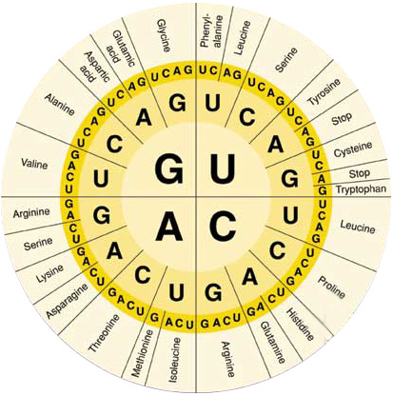
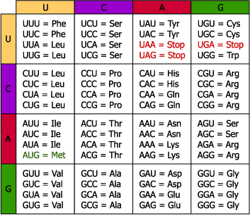
Figure 1.The genetic code.

A | Alanine | Ala
C | Cysteine | Cys
D | Aspartate  (aspartic acid) | Asp
E | Glutamate  (glutamic acid) | Glu
F | Phenylalanine | Phe
G | Glycine | Gly
H | Histidine | His
I | Isoleucine | Ile
K | Lysine | Lys
L | Leucine | Leu
M | Methionine | Met
N | Asparagine | Asn
P | Proline | Pro
Q | Glutamine | Gln
R | Arginine | Arg
S | Serine | Ser
T | Threonine | Thr
V | Valine | Val
W | Tryptophan | Trp
Y | Tyrosine | Tyr

Figure 2.Amino acid names and abbreviations.

Chapter 2
Gene variants &Polymorphisms
Problems

1. This is the sequence of the first exon of a mouse gene.
CGGGCACCATGAGCGACGTGGCTATTGTG…
a) What would be the consequence of deleting the boxed nucleotides? Please write down the protein sequences before and after the mutation.

b) What would be the expected impact of this deletion on the protein function?

2. The following sequence is located at the beginning of a gene.
The underlined part corresponds to an intron, which flanks two exons.

ATTAGCCATGCTCTCCGTCCCAACTGTAAGTATGCGCGAGATCGTTACCAGGATGATTGT…
What would be the expected impact of the following mutations:
- ATTAGCCATGCTGTCCGTCCCAACTGTAAGTATGCGCGAGATCGTTACCAGGATGAT…
C to G
- ATTAGCCATGCTCTCCGTCCCAACTGTAAGTATGAACGAGATCGTTACCAGGATGAT…
CG to AA

- ATTGGCCATGCTCTCCGTCCCAACTGTAAGTATGCGCGAGATCGTTACCAGGATGAT…
A to G

3. A research team sequenced a human gene and the corresponding mRNA. Here is the sequence of the genomic DNA. The parts that are identical between the genomic DNA and the mRNA are written using uppercase letters.

agcgaaatttaatgagcgtgtaacaggggactgaaaatcctgatttctcaAGCTATCAAA
del 1
GGTTTATAAAGCCAATATCTGGGAAAGAGAAAACCGTGAGACTTCCAGATCTTCTCTGGT
GAAGTGTGTTTCCTGCAACGATCACGAACATAAACATCAAAGGATCGCCATGGAAAGgta
del 2
agtgtgacaactcactgcgttggtggctcgcgttcttatgagctaagGGTCCCTCCTGCT
GCTGCTGGTGTCAAACCTGCTCCTGTGCCAGAGCGTGACCCCCTTGCCCATCTGTCCCGG
Del 3
CGGGGCTGCCCGATGCCAGGTGACCCTTCGAGACCTGTTTGACCGCGCCGTCGTCCTGTC

CCACTACATCCATAACCTCTCCTCAGAAATGTTCAGCGAATTCgtaagtaccatgcttct
ggcttcctattgaatttgtctcatcatttccagGATAAACGGTATACCCATGGCCGGGGG
del 4
TTCATTACCAAGGCCATCAACAGCTGCCACACTTCTTCCCTTGCCACCCCCGAAGACAAGGA
GCAAGCCCAACAGATGAATgtgagtccttcatccaggctttgca

- Which parts of that sequence correspond to exons, introns and promoter?
- What is the sequence of the peptide encoded by this gene (first ten residues)?
- What will be the impact of each of the deletions indicated by boxed nucleotides on the protein sequence and length?

4.
a) Gene B has 390 Guanine and the total number of hydrogen bonds is 1670, is substitution mutated in 1 pair of nucleotides to gene b. Gene b has 1 hydrogen bond more than gene B. Calculate each type of nucleotide in gene b.

b) Gene X has 3600 hydrogen bonds and the number of nucleotide Adenine is equal to 30% the number nucleotide of the whole gene. Gene X is mutated type deletion 1 pair of nucletode A-T to gene x.
A cell with heterozygote genotype Xx undergoes mitosis to 2 daughter cells. Please calculate each type of nucleotide that the environment need to provide to the process.

5.
a) A gene D has 4800 hydrogen bonds and the ratio of nucleotide number Adenine/Guanine = 1/2, , is substitution mutated in 1 pair of nucleotides to gene d with 4801 hydrogen bonds. Calculate each type of nucleotide in gene D and d.

b) Gene A with 3000 hydrogen bonds and the number of nucleotide Adenine is equal to Guanine, is mutated to gene a. When gene a underwent DNA replication, the environment provided 2398 nucleotides. Which kind of mutation that gene A had?

6. This is the result of a paternity test of an alleged father (Jim Doe) and child (John). Please check if Jim is biological father of John, in case yes, point out which allele the child inherited from the father.

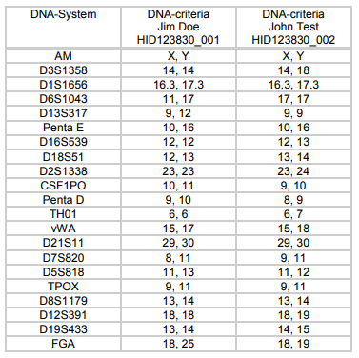

7. Using the genetic code table (attached), fill in the amino acid sequence starting with the first ATG of the coding strand. It helps to mark off the codons by threes.

DNA (5')G G A T A G C A T G A A A C C C G C A T A A (3')
amino acid :

How would the amino acid sequence above change with the following changes (mutations) in the DNA code (changes are marked in bold-face):
a. (5')G G A T A G C A T G A A A C C A G C A T A A (3') change to T
amino acid:

b. (5')G G A T A G C A T G A A A C C C C C A T A A (3') change to A
amino acid:

c. (5')G G A T A G C A T G A A A - C C G C A T A A (3') delete
amino acid :

d. (5')G G A T A G C A T G T A A C C C G C A T A A (3') change to C
amino acid :

8. A diploid organism with 4000 spermatocytes undergoes meiosis to produce gametes. During meiosis there are 40 cells with 1 pair of unseparated chromosomes in meiosis I, meiosis II took place normally, the rest of the cells meiosis normally. Please indicate:
a) What is the percentage of non-mutated gametes?
b) What percentage of mutant gametes that have more 1 chromosome than normal?

c) What percentage of mutant gametes that have less 1 chromosome than normal?

9. In Drosophila (2n=8), an individual has two chromosomal structure mutations: a chromosome in the 1st pair carries deletion mutation, and a chromosome in the 3rd pair carries inversion mutation. If the meiosis process takes place normally, please calculate:
a. Percentage of the normal gametes?
b. Percentage of the gametes carry the deletion chromosome?
c. Percentage of the gametes carry both the deletion chromosome and the inversion chromosome?

Chapter 3
MENDEL’s laws

Problems
1. Here are four pedig rees. The black symbols rep resent patients suffering from a rare disease that is transmitted according to Mendel’s law.

- For each family, determine whether the trait is dominant or recessive.
- Determine the genotypes of the affected individuals and their parents.

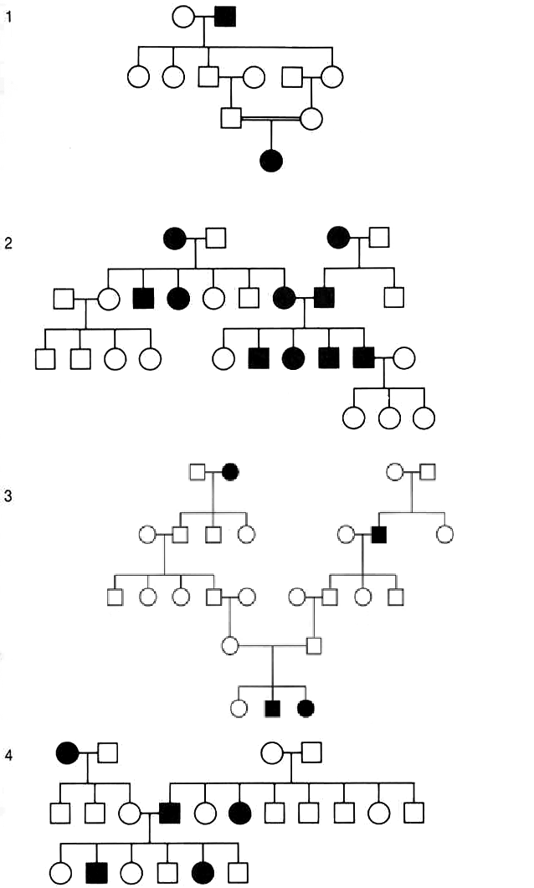

2. Crossing two drosophila flies (both) with normal wings produces 27 individuals with short wingsand 79 with normal wings.
a) How is the short wings trait transmitted?
b) What are the parents genotypes?
c) If flies with short wings are crossed with one of the parent flies, how many normal flies are expected in an offspring of 120 flies?
3. Albinism in plants is the inability to make chlorophyll. It is a recessive trait. In an experiment, heterozygous tobacco plants undergo auto-fertilization and produce 600 seeds, of which 80% germinate.
a) How many albino plants will be obtained?
b) How many plants will show the parental genotype?
4. The ability to taste phenylthiourea (or phenylthiocarbamide) is a genetic trait that is transmitted according to Mendel’s laws. Tasters are able to recognize a solution containing only 0.005% of this product, by contrast to non-tasters, who are not able to detect this molecule even at much higher concentrations.
Two parents who are both able to taste phenylthiourea have four children, of whom two are unable to taste the molecule.
a) How is this trait transmitted?
b) What are the parents’ genotypes?
c) If this couple has a fifth child, what is the probability that the child is able to taste phenylthiourea?
5. Normal human skin pigmentation is dominant over the albino trait. If an albino man expects a child with a woman who has normal skin pigmentation and whose father was albino, what are the possible ge notypes and phenotypes of the child?
6. In this pedigree, patient represented by a black symbol are born deaf.
a) What can be concluded in term of transmission of this trait?
b) What are the possible genotypes of individual III2?
7. The dominant allele A in Ayrhirecows produces a cut in the ears. In the following pedigree, in which black symbols represent individuals with cut ears, determine thefrequency of this trait in the offspring from the following matings: (a) III1 X III3 (b) III2 X III3 (c) III3 X III4 (d) III1 X III5 (e) III2 X III5
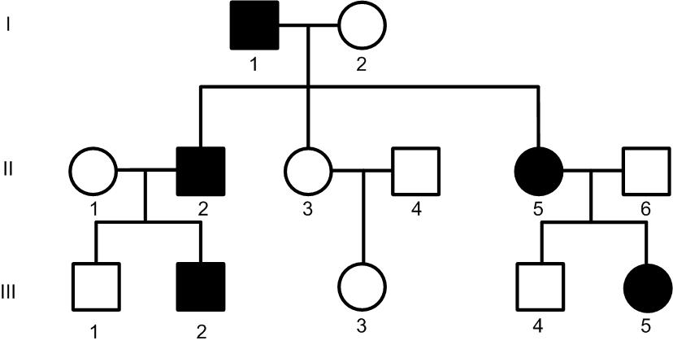

8. In Linumusitatissimum (flax, used to make linen textile), the blue color of the flowers (b) and the long fiber length (l) are recessive traits. A farmer mate true breeding plants with short fibers and white flowers with plants with blue flowers and long fibers.
a) What are the genotypes of these plants?
b) What is the geno type of the F1generation?
c) If plants from F1 are auto-fertilized and 800 F2 plants are obtained,
1. calculate the expected number of plants with white flowers and long fibers
2. determine the percentage of the different genotypes among these (white flowers and long fibers).
9. In a bovine population, two co-dominant alleles control the coat color: R (red) and r (white). Heterozygous individuals present an intermediate color named “rouan”. The “strait hair” trait is dominant over the “curly” trait (s). What is the result of mating a red curly bull with a homozygous white cow with strait hair?
a) What is the offspring phenotype?
b) What is the offspring and parents genotype?
c) What is the result of mating a F1individual with a rouan curly bull?
10. Short hair is a dominant trait in guinea pigs and is controlled by a single gene (allele L), while the allele l corresponds to long hair. The fur color is controlled by a gene which has two co-dominant alleles, such that: the YY genotype = yellow, YW = cream and WW = white. If individuals that have the genotype Ll YW are mated, what will be the possible phenotypes in the F1 generation and the percentages?
11. A man with Huntington disease (autosomal dominant – rare diseases) and the AB blood group married a healthy woman who is O. The genes are independent. What is the probability that their child is healthy and A?
12. Two male drosophila flies (1 & 2) are mated with two females (3 & 4). These parents have long wings and a grey body.The results of the mating are:
1 x 3 : 153 grey individualswith long wings
58 grey individuals with wing remnants
1 x 4 : 26 black individuals with long wings
73 grey individuals with long wings
2 x 3 : 112 grey individuals with long wings
2 x 4 : 89 grey individuals with long wings
What are the parent genotypes?

Chapter 4
Particular cases including crossing over
Problems
1. A farmer crosses two true breeding types of peonies: one has red flowers with large leaves (R and G dominant alleles, respectively), the other is white with small leaves.
- If these two traits are controlled by two genes, what will be the phenotype of the F1 offspring?
- If F1 individuals undergo auto-fertilization, what will be the percentages of each phenotype in F2 if the two genes are independent?
- Same if the two genes are tightly linked?
- Same if the two genes are separated by a distance of 10 Morgan units (centimorgan)?

2. The success of renal transplantation depends on three human histocompatibility genes, HLA-A, HLA-B and HLA-C, which must match between the donor and the receiver. A single mismatch may cause the kidney rejection. Each gene has multiple co-dominant alleles. These three genes are located very close to each other on chromosome 6, so that the recombination rate is very low (below 1%).
The father has the following genotype: A1, A2, B24, B10, Cw4 and Cw7 and the mother is A1, A1, B11, B7, Cw5 and Cw8. Their first boy is A1, A1, B24, B11, Cw7 and Cw8. What is the probability that the second child is compatible with his/her brother?
3. Wild type drosophila are mated with mutants with yellow eyes (s phenotype) and no antenna (bobbed or B phenotype). F1 offspring have wild type eyes and “bobbed” antennas. When F1 individuals are mated, the F2 result is the following:
101 individuals are [wt B]
32 individuals are [wt wt]
31 individuals are [s B]
13 individuals are [s wt]
a) Are these genes linked?
b) What are the genotypes of the parents and the F1 individuals?
4. A man inherited cataract from his mother (normal fingers and toes) and polydactyly from his father (normal eyes). The two diseases are caused by dominant alleles of genes that are tightly linked. This man marries a healthy woman. What will be the phenotype of the children?
5. Here is a mapof the locus for the a, b and c genes:
a/A b/B c/C

10 cM 15 cM
What will be the percentages of gametes produced by an individual who is A-b-C ?
a-B-c
6. Two types of drosophila are studied:
Wild type flies: red eye (red)
Grey body (grey)
Normal wings (norm)
mutants: chestnut eye (ch)
black body (bl)
indented wings (ind)
Wild type males are mated with mutant females.The F1 population is wild type.Then,
- a F1 female is mated with a mutant male (offspring = F2a)
- a F1 male is mated with a mutant female (offspring = F2b)

Here are the phenotypes of the two populations F2a and F2b:
1. F2a
Eye | red | red | red | Red | Ch | ch | Ch | ch
Body | grey | grey | bl | Bl | Grey | grey | Bl | bl
Wings | norm | ind | norm | Ind | Norm | ind | norm | ind
 | 616 | 65 | 170 | 147 | 144 | 172 | 66 | 620
2. F2b
eye | red | ch
body | grey | bl
wings | norm | ind
 | 542 | 551
a) How would you explain the F2b results?
b) Determine the genetic map of the locus.
7. In experiments using drosophila confuse, researchers observed that the vermillon trait (v allele) is responsible for dark red eyes. If homozygous a wild type female (light red eyes) is mated with a vermillon male (mating A), the offspring includes 61 wild type females and 57 wild type males. If a vermillon female is mated with a wild type male (mating B), the offspring is 88 wild type females and 79 vermillon males.
a) How would you interpret these results?
b) What are the parents and F1genotypes?
c) If F1individuals are mated, what phenotypes and percentages will be observed in F2?
8. A healthy woman, whose father died from hemophilia (X-linked recessive), married a healthy man. Could their children suffer from hemophilia?
Chapter 5
POPULATION GENETICS
Problems
1. In the course of a study dealing with blood group frequencies in a population of 2000 individuals, part of the results were lost. We know that 800 individuals were O and 780 were A.
a) What are the allelic frequencies?
b) What are the phenotype frequencies?
2. A. If the frequency of albino (recessive trait) in a given population is 0.0009, what will be the frequency of heterozygous individuals?
B. Huntington disease (autosomal dominant) has a frequency of 1 case in 25 000. Calculate the frequency of the mutated allele in the population.
3. A. If, in 5% of men are color blind (recessive X-linked trait) in a given population, what will be the frequency of color blind women?
B. If allele frequencies corresponding to the blood group gene was: p(A) = 0.3 ; q(B) = 0.1 ; r(o) = 0.6, what will be the phenotype percentages?
4. A. The ability to taste phenylthiocarbamide is a dominant trait in humans controlled by allele G of a gene. In a given population, 2800 individuals are able to taste this molecule while 1200 do not.
a) What are the allele frequencies?
b) What are the genotype frequencies?
B. In humans, the Rh factor genetic information is inherited from our parents, but it is inherited independently of the ABO blood type alleles. In humans, Rh+ individuals have the Rh antigen on their red blood cells, while Rh− individuals do not. There are two different alleles for the Rh factor known as Rh+ and rh. Assume that a dominant gene Rh produces the Rh+ phenotype, and that the recessive rh allele produces the Rh− phenotype. In a population that is in Hardy-Weinberg equilibrium, if 190 out of 200 individuals are Rh+, calculate the frequencies of both alleles.
5. Premature baldness is a trait influenced by sex: it is dominant in men and recessive in women. In a study of 10000 men, 7225 were not bald. How many individuals are expected to have normal hair in a population of 10000 women?
6. A. An allele W, for white wool, is dominant over allele w, for black wool in a sheep. In a sample of 900 sheep, 891 are white and 9 are black. Calculate the allelic frequencies within this population, assuming that the population is in H-W equilibrium.
B. In the United States, approximately one child in 10,000 is born with PKU (phenylketonuria), a syndrome that affects individuals homozygous for the recessive allele (aa).
(a) Calculate the frequency of this allele in the population.
(b) Calculate the frequency of the normal allele.
(c) Calculate the percentage of carriers of the trait within the population.

7. In cats, the gene for hair color is located on a non-homologous region of the X chromosome: the dominant allele for black hair is completely dominant over the recessive allele for tabby hair, individuals with the heterozygous genotype has calico hairs. . A cat population is in genetic equilibrium with 10% male tabby cats. Theoretically, if the population has 1000 cats, how many calico cats are expected ?

8. In sheep, allele D codes for horns, allele d for no horns; genotype Dd for horns in males and no horns in females. In a population in genetic equilibrium, sheep have 50% horns. All hornless sheep in this population are randomly mated to obtain F1. Theoretically, in F1, what is the ratio of hornless sheep that can be expected ?

